**Fusion Splicing Optical Fibers**

Student Version



Huawei Technologies Co., Ltd.

|  |
| --- |
| **Copyright © Huawei Technologies Co., Ltd. 2020. All rights reserved.**  No part of this document may be reproduced or transmitted in any form or by any means without prior written consent of Huawei Technologies Co., Ltd.  **Trademarks and Permissions**  HW_POS_RBG_Vertical-150ppi.png and other Huawei trademarks are trademarks of Huawei Technologies Co., Ltd.  All other trademarks and trade names mentioned in this document are the property of their respective holders.  **Notice**  The purchased products, services and features are stipulated by the contract made between Huawei and the customer. All or part of the products, services and features described in this document may not be within the purchase scope or the usage scope. Unless otherwise specified in the contract, all statements, information, and recommendations in this document are provided "AS IS" without warranties, guarantees or representations of any kind, either express or implied.  The information in this document is subject to change without notice. Every effort has been made in the preparation of this document to ensure accuracy of the contents, but all statements, information, and recommendations in this document do not constitute a warranty of any kind, express or implied. |

|  |  |
| --- | --- |
| Huawei Technologies Co., Ltd. | |
| Address: | Huawei Industrial Base  Bantian, Longgang  Shenzhen 518129  People's Republic of China |
| Website: | <https://e.huawei.com/> |

**Huawei Certification System**

Huawei Certification follows the "platform + ecosystem" development strategy, which is a new collaborative architecture of ICT infrastructure based on "Cloud-Pipe-Terminal". Huawei has set up a complete certification system consisting of three categories: ICT infrastructure certification, platform and service certification, and ICT vertical certification. It is the only certification system that covers all ICT technical fields in the industry. Huawei offers three levels of certification: Huawei Certified ICT Associate (HCIA), Huawei Certified ICT Professional (HCIP), and Huawei Certified ICT Expert (HCIE). Huawei Certification covers all ICT fields and adapts to the industry trend of ICT convergence. With its leading talent development system and certification standards, it is committed to fostering new ICT talent in the digital era, and building a sound ICT talent ecosystem.

Huawei Certified ICT Associate-Datacom (HCIA-Datacom) is designed for Huawei's frontline engineers and anyone who want to understand Huawei's datacom products and technologies. The HCIA-Datacom certification covers routing and switching principles, basic WLAN principles, network security basics, network management and O&M basics, SDN and programmability and automation basics.

The Huawei certification system introduces the industry, fosters innovation, and imparts cutting-edge datacom knowledge.

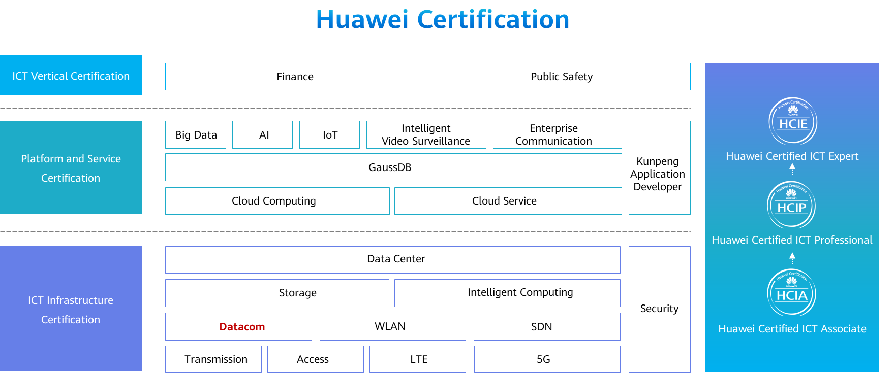

# Fusion Splicing Optical Fibers

## Background

John has just joined a company as an intern and participated in an integrated cabling project. Currently, the project is in the early stage of optical cable routing for the campus subsystem. An important part of optical cable routing is to implement fiber to the home (FTTH). John is assigned a task of fusion splicing optical fibers in a 12-core fiber access terminal (FAT) in a corridor.

## Objectives

Upon completion of this exercise, you will be able to:

* Master the fusion splicing procedure of optical fibers.
* Use a fiber fusion splicer.
* Use other tools involved in fusion splicing.
* Be familiar with the structure, working mechanism, and classification of optical fibers.
* Be familiar with 12-core FATs.

## Topology

Campus subsystem

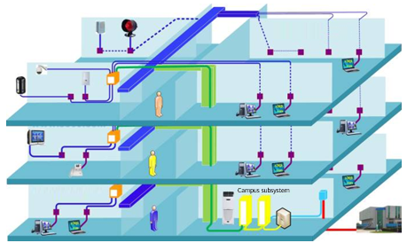

EPON network topology



## Planning

This exercise describes how to fusion splice the single-mode optical fibers in an FAT (see Figure 1-2) located in a corridor for the optical cable routing project of the campus subsystem (see Figure 1-1). An optical cable and a 12-core pigtail need to be fusion spliced.

### Preparations

Prepare instruments, including a fiber fusion splicer and a visual fault locator.

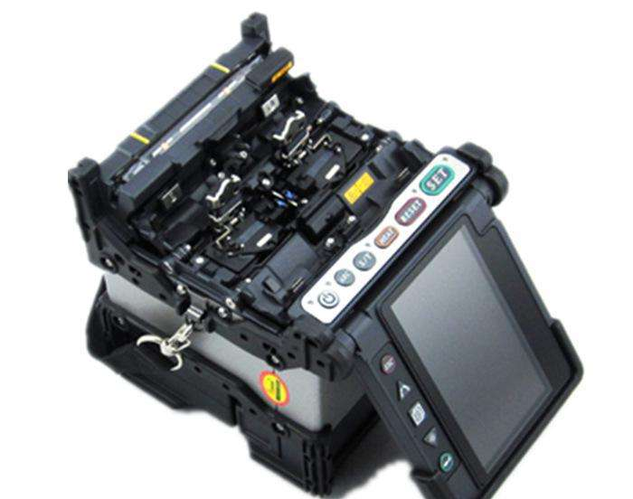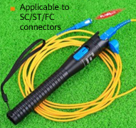

Prepare tools, including a fiber cleaver, a three-hole fiber stripper, a pair of scissors, and an alcohol container.

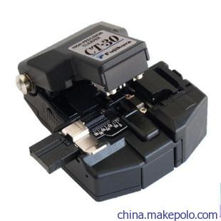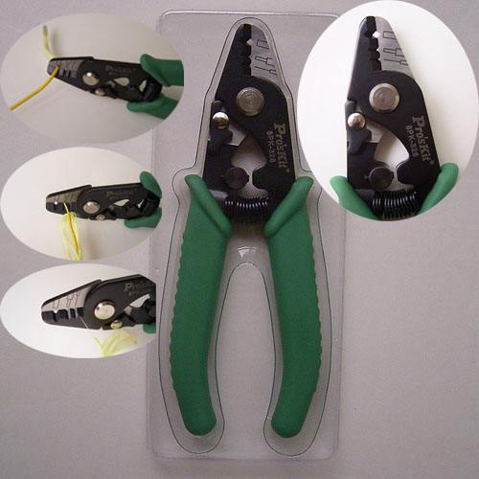

Prepare materials, including 12 heat-shrink protective sleeves and fiber cleaning wipes.

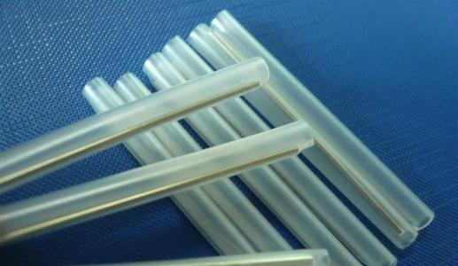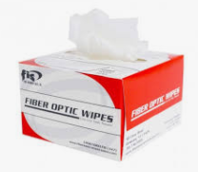

### Tasks

Sort optical fibers by color.

Introduce optical fibers into heat-shrink protective sleeves.

Peel off the protective layers of optical fibers.

Remove the resin layers from optical fibers.

Clean optical fibers.

Cut optical fibers.

Place optical fibers into a fusion splicer.

Fusion splice optical fibers.

Heat the heat-shrink protective sleeves.

Take out the heated optical fibers from the fusion splicer.

Perform continuity tests.

Perform onsite "5S".



5S indicates five Japanese words: seiri, seiton, seisō, seiketsu, and shitsuke. These have been translated as "Sort", "Set in order", "Shine", "Standardize", and "Sustain".

----End

## Implementation

Sort optical fibers by color.

An optical cable and a 12-core pigtail need to be fusion spliced. Sort the optical fibers at both ends by color in the following sequences: blue, orange, green, brown, gray, white, red, black, yellow, purple, pink, and dark green.

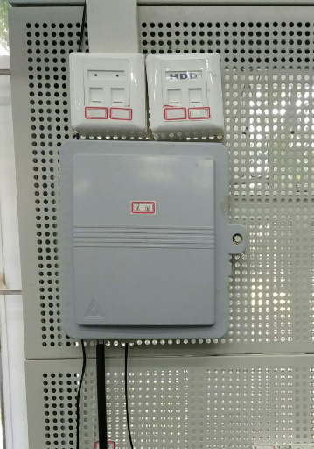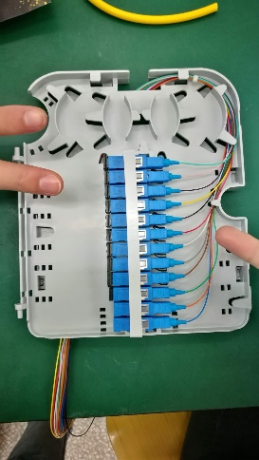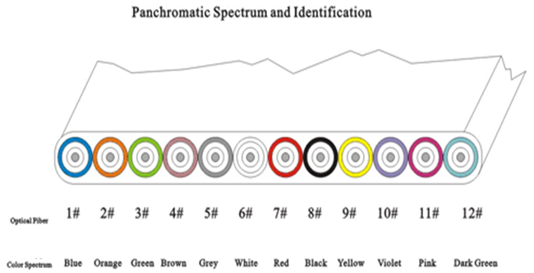

Introduce optical fibers into heat-shrink protective sleeves.

Introduce each optical fiber of the 12-core pigtail into a heat-shrink protective sleeve.

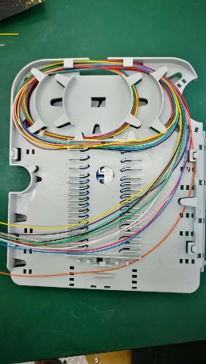

Peel off the protective layers of optical fibers.

First, take the blue optical fiber of the pigtail.

Hold the optical fiber between the thumb and index finger of your left hand and keep it level, leaving 5-cm exposed fiber before the fingers. Make the remaining optical fiber curve naturally between your ring finger and little finger to avoid slipping.

Hold a fiber stripper with your right hand. Clamp the optical fiber gently using the middle hole of the fiber stripper, keeping the fiber stripper almost vertical to the optical fiber with the upper part slightly tilted inward. The recommended length of the optical fiber to be stripped is 3–4 cm.

Then, strip the optical fiber directly and smoothly along the fiber axis.

Now, you can see the optical fiber without protective layers, which is easily broken. Therefore, you must hold the bare fiber carefully to avoid any possible damage.

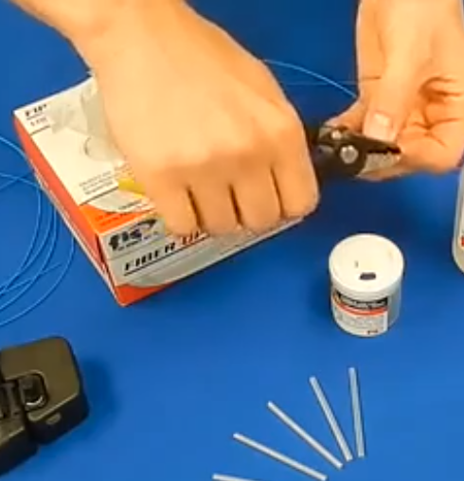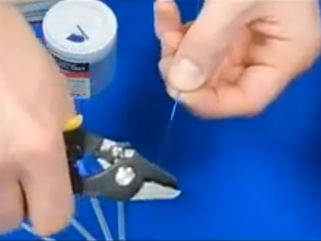

Remove the resin layers from optical fiber.

Use the smallest hole of the fiber stripper to remove the resin layer of the optical fiber. You'll see the resin residue left on the blade.

Then, strip the blue optical fiber of the optical cable in the same way.

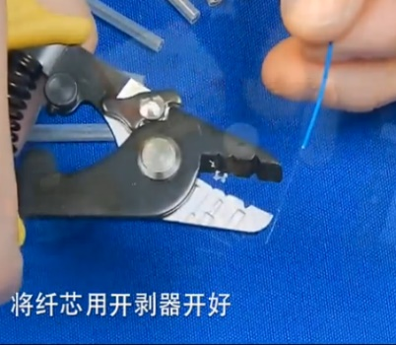

Clean the bare fibers.

Gently slide a fiber cleaning wipe towards the end of a bare fiber once or twice, using a different part of the wipe for the second clean to avoid contamination.

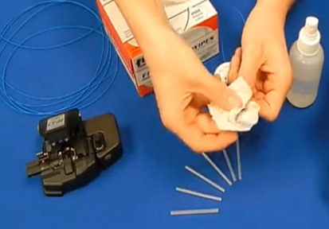

Clean the bare fiber of the other cable.

Cut optical fibers.

Cutting is the most important part of the fusion splicing process. Therefore, you must be trained before performing this operation.

Place the fiber cleaver on a stable desk and push the blade in place.

Place the optical fiber into the V-groove of the fiber cleaver, and align the edge of the fiber outer jacket with the 16 mm scale. The scale indicates the spacing between the blade and the edge of the fiber outer jacket. The recommended spacing is about 15 mm. The cutting length varies according to the models of heat-shrink protective sleeves. For details, see the product user guide.

Flip down the magnetic panel to hold the optical fiber firmly in place. Then, close the cleaver and press the button with proper force. Ensure this operation is performed smoothly and stably. When you open the lid of the fiber cleaver, you will see the cleaved fiber. The cutting surface of the bare fiber must be neat and clean. Any of the following situations is not accepted: broken fiber, incorrect cutting angle, burrs, and cracks.

In following steps, ensure that the fiber will not be damaged or contaminated.

Cut the bare fiber of the other cable in the same way.

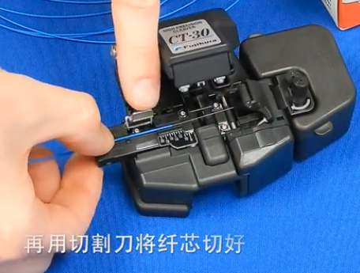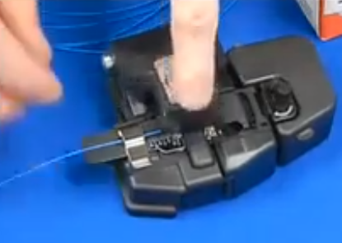

Place the cleaved fibers into the fusion splicer.

Lift up the wind cover of the fusion splicer, and then the left and right magnetic flaps.

Carefully place the cleaved fiber into the left or right V-groove of the fusion splicer. Ensure that the tip of the fiber does not cross over the electrode. You also need to protect the end face of the fiber from touching any objects, including the V-groove, so as to prevent contamination or damage.

Flip down the magnetic flap to hold the optical fiber in place.

Start the same process over again to place another optical fiber into the V-groove at the other side of the fusion splicer.

Close the wind cover.

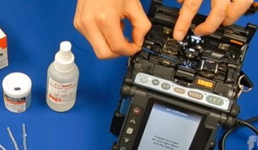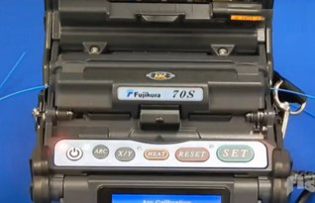

Fusion splice optical fibers.

Press the **SET** button to start the fusion splicing, and observe the liquid crystal display (LCD).

With default settings, the fusion splicer automatically lines up the fibers and fusion splices them. During this process, the fusion splicer measures the cutting angle of each bare fiber, aligns bare fibers in the X and Y fields, and then generates high-voltage electric arcs to fusion splice the fibers. You can view the fiber images on the LCD, as well as the causes of fusion splicing exceptions, such as incorrect cutting angles, bubbles, large spacing between tips of the two bare fibers, or a mismatch between the core dimensions of the bare fibers.

The estimated loss (unit: dB) is displayed on the LCD. If the value exceeds the splicing loss threshold, an error message is displayed. In this case, you are advised to fusion splice the optical fibers again.

The fusion splicer automatically saves the splicing result.

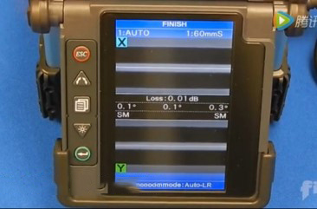

Heat the heat-shrink protective sleeves.

Lift up the lid of the heater.

Lift up the wind cover, lift up the left magnetic flap, and hold the optical fiber with your left hand. Then, lift up the right magnetic flap and hold the optical fiber with your right hand. Gently take out the fusion-spliced optical fiber.

Gently slide the heat-shrink protective sleeve over the splice. Ensure that there is an even amount of clad fiber on both sides. Then, carefully place the protective sleeve into the heater. Ensure that the stainless steel rod in the protective sleeve is underneath and in the center of the heater.

Close the lid of the heater.

Press the **HEAT** button to start heating. The heat indicator turns on. When the heating is complete, the fusion splicer beeps and the heat indicator is off.

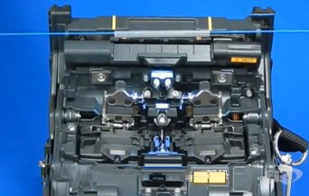

Take out the heated optical fiber from the fusion splicer.

Lift up the heater lid and take out the heated optical fiber carefully. Do not touch the protective sleeve as it is still hot.

Ensure that there are no bubbles or impurities in the protective sleeve, and then put it into the cooling tray.

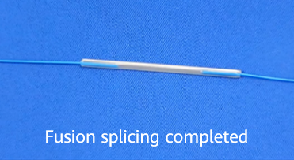

Perform continuity tests.

Connect the optical port of the visual fault locator to the pigtail.

Turn on the visual fault locator.

Observe the other end of the pigtail. If you can see red light, the fiber continuity is in good condition.

A visual fault locator can only test the continuity of an optical fiber, but cannot measure the loss or locate the failure point.

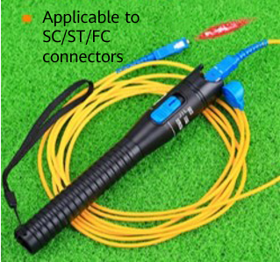

Perform onsite "5S".

----End

## Project Result Records

### Data Record

|  |  |  |  |  |  |  |
| --- | --- | --- | --- | --- | --- | --- |
| Splice Point No.  Optical Cable-Pigtail | 1-1 | 2-2 | 3-3 | 4-4 | 5-5 | 6-6 |
| Fiber Color  (Sorted by Color) |  |  |  |  |  |  |
| Estimated Loss (dB) |  |  |  |  |  |  |
| Continuity Test  (Whether You Can See Red Light at the Other End of the Fiber) |  |  |  |  |  |  |
| Splice Point No.  Optical Cable-Pigtail | 7-7 | 8-8 | 9-9 | 10-10 | 11-11 | 12-12 |
| Fiber Color  (Sorted by Color) |  |  |  |  |  |  |
| Estimated Loss (dB) |  |  |  |  |  |  |
| Continuity Test  (Whether You Can See Red Light at the Other End of the Fiber) |  |  |  |  |  |  |

### Process Self-Assessment

| Self-Assessment Dimensions (Whether Requirements Are Met) | Whether Optical Fibers Are Correctly Arranged by Color | No Bubble or Impurity in the Heated Protective Sleeve | Bare Fibers Completely Protected by the Protective Sleeve | Even Amount of Bare Fibers at Both Sides of the Protective Sleeve |
| --- | --- | --- | --- | --- |
| 1 |  |  |  |  |
| 2 |  |  |  |  |
| 3 |  |  |  |  |
| 4 |  |  |  |  |
| 5 |  |  |  |  |
| 6 |  |  |  |  |
| 7 |  |  |  |  |
| 8 |  |  |  |  |
| 9 |  |  |  |  |
| 10 |  |  |  |  |
| 11 |  |  |  |  |
| 12 |  |  |  |  |

### Operation Self-Assessment

|  |  |  |  |  |  |
| --- | --- | --- | --- | --- | --- |
| Score | Procedure | Use of Instruments | Use of Tools | Operation Standardization | Onsite "5S" |
|  |  |  |  |  |